Evaluating Intraoperative Infusion of Low Dose Ketamine vs. Low Dose Ketamine and Dexmedetomidines Perioperatively in Head and Neck Surgeries
Abstract
Background: Head and neck surgeries are often associated with significant postoperative pain and hemodynamic instability. Opioid-sparing strategies are essential to improve recovery outcomes and minimize opioid-related adverse effects. This study aimed to compare the analgesic efficacy and perioperative effects of intraoperative low-dose ketamine versus a perioperative combination of low-dose ketamine and dexmedetomidine.
Methods: A prospective, randomized, double-blind clinical trial was conducted on 90 adult patients undergoing elective head and neck surgery. Patients were assigned to one of three groups (n=30 each): normal saline (control), intraoperative ketamine infusion (0.3 mg/kg/h), or perioperative ketamine (0.3 mg/kg/h) plus dexmedetomidine (0.5 µg/kg/h). The primary outcome was postoperative pain score assessed via the Numeric Rating Scale (NRS) at multiple intervals. Secondary outcomes included total morphine consumption, time to first rescue analgesia, hemodynamic stability, and patient satisfaction.
Results: The ketamine–dexmedetomidine group reported significantly lower pain scores across all time points, with a median NRS of 1 at 24 hours compared to 1 in the ketamine group and 3 in the control group. This group also showed the longest time to first analgesia request [median 18 hours], and the lowest morphine requirement [median 10 mg] versus 9 hours/15 mg in the ketamine group and 3 hours/20 mg in controls. Heart rate and mean arterial pressure were consistently more stable in the combination group. Satisfaction was highest in the ketamine–dexmedetomidine group (50% excellent rating).
Conclusion: Perioperative infusion of ketamine and dexmedetomidine provides superior analgesia, better hemodynamic stability, and higher patient satisfaction compared to ketamine alone or control. This combination may serve as an effective opioid-sparing strategy in major head and neck surgeries.
Keywords: Ketamine, Dexmedetomidine, Head and Neck Surgery, Postoperative Pain, Hemodynamic Stability.
Introduction
Head and neck surgeries are complex, lengthy procedures often associated with significant blood loss and hemodynamic instability. Maintaining intraoperative stability and ensuring smooth emergence from anesthesia are crucial to minimize postoperative complications, especially in surgeries involving major vascular structures (1). Agitation and coughing during extubation can provoke dangerous fluctuations in heart rate and blood pressure, increasing the risk of adverse outcomes. Therefore, effective perioperative anesthetic management and pain control are essential to enhance recovery, reduce morbidity, and improve overall prognosis (2).
Adequate postoperative analgesia not only facilitates early recovery and mobility but also prevents complications such as wound infections, thromboembolism, and prolonged hospitalization. While opioids remain the cornerstone of pain relief, their use is limited by side effects like respiratory depression and tolerance (3). Ketamine, an NMDA receptor antagonist, offers effective analgesia at low doses, reducing opioid requirements and associated risks (4). Similarly, dexmedetomidine provides hemodynamic stability and analgesic-sparing effects without respiratory depression, though its delayed onset limits its utility. Combining ketamine with dexmedetomidine may enhance analgesia while minimizing the individual drawbacks of each drug (5, 6).
Therefore, the aim of this study is to compare the analgesic efficacy of intraoperative infusion of low dose ketamine vs. low dose ketamine and dexmedetomidines perioperatively in head and neck surgeries.
Patients and Method
Study design and population
This prospective, randomized, double-blinded clinical trial was conducted at Benha University Hospitals over a 12-month period following institutional ethical approval. The study included 90 adult patients scheduled for elective head and neck surgeries under general anesthesia. All patients were aged over 18 years, of either sex, and classified as American Society of Anesthesiologists (ASA) physical status I or II. Informed written consent was obtained after full explanation of the study purpose. Each patient was assigned a unique code to ensure confidentiality.
Inclusion and Exclusion Criteria
Participants were included if they were over 18 years of age, of either sex, and undergoing elective head and neck surgery with ASA class I or II. Patients were excluded if they had known hypersensitivity to ketamine or dexmedetomidine, a history of substance abuse, chronic opioid use, psychiatric illness, seizures, uncontrolled hypertension or diabetes mellitus, heart block, were receiving anticoagulants.
Randomization and Blinding
Eligible patients were randomly assigned into three equal groups of 30 using computer-generated random numbers placed in sealed opaque envelopes. Group allocation was carried out by a designated nurse not involved in the study or data collection. The control group received normal saline as a bolus and infusion. The ketamine group received intraoperative infusion of ketamine at a rate of 0.3 mg/kg/h starting after induction and continued until ten minutes before the end of surgery. The third group received combined infusion of ketamine at 0.3 mg/kg/h and dexmedetomidine at 0.5 µg/kg/h, starting at induction and maintained throughout the surgery.
Anesthetic Management
All patients received a standardized anesthetic technique. Induction of anesthesia was achieved with lidocaine (0.5 mg/kg ideal body weight), propofol (1.5 mg/kg lean body weight), fentanyl (1.0 µg/kg total body weight), and rocuronium (1.1 mg/kg ideal body weight). Muscle relaxation was maintained with additional doses of rocuronium guided by neuromuscular monitoring. Anesthesia was maintained using sevoflurane in a mixture of air and oxygen, titrated to maintain a bispectral index score between 40 and 60. Mechanical ventilation was adjusted to achieve normocapnia, and intraoperative vital signs were recorded every five minutes.
Postoperative Analgesia Protocol
Pain was assessed using the Numeric Rating Scale (NRS) ranging from 0 (no pain) to 10 (worst pain) (7). Patients were educated preoperatively about the NRS. Pain scores were recorded at 0, 30, and 60 minutes and at 2, 6, 12, and 24 hours postoperatively. All patients received 1 gram of intravenous paracetamol every six hours for the first 24 hours. Rescue analgesia in the form of 4 mg intravenous morphine was administered as needed when the NRS was 4 or higher, with a minimum interval of six hours between doses. Total morphine consumption during the first 24 hours was calculated for each patient.
Outcome Measures
The primary outcome of the study was the postoperative pain score measured using the NRS at 1, 2, 4, 8, 12, 16, and 24 hours after surgery. Secondary outcomes included total morphine consumption in the first 24 hours, time to first request for rescue analgesia, hemodynamic parameters including heart rate and mean arterial pressure, and patient satisfaction. Satisfaction was assessed at discharge using a 4-point verbal rating scale ranging from 1 (excellent) to 4 (poor). Occurrence of adverse events such as bradycardia, hypotension, nausea, vomiting, respiratory depression, or any other complications was also documented.
Data Collection and Monitoring
All intraoperative data were collected by an anesthesiologist involved in patient care, while postoperative data were recorded by an assessor blinded to the group allocation. Parameters recorded included patient demographics, duration of surgery, intraoperative and postoperative hemodynamics, pain scores, morphine requirements, time to first analgesic request, patient satisfaction, and any adverse events encountered during the 24-hour postoperative period.
Statistical Methods
Data management and statistical analysis were done using SPSS version 27 (IBM, Armonk, New York, United States). Quantitative data were assessed for normality using the Shapiro-Wilk test and direct data visualization methods. According to normality, quantitative data were summarized as means and standard deviations or medians and ranges. Categorical data were summarized as numbers and percentages. Quantitative data were compared across the groups using one-way ANOVA and Kruskal-Wallis tests for parametric and non-parametric variables, respectively. Post-hoc analysis was done in case of a significant overall effect. All post-hoc analyses were Bonferroni adjusted. Categorical data were compared using the Chi-square or Fisher’s exact test. Multivariate linear regression analyses were performed for prediction of numeric Rating Scale (NRS), time to first rescue analgesia, and total morphine consumption. The regression coefficient with 95% confidence intervals were calculated. Multivariate logistic regression analysis was done to predict patients’ satisfaction. The odds ratios with 95% confidence intervals were calculated. All statistical tests were two-sided. P values less than 0.05 were considered significant.
Results
The studied groups were comparable regarding age (P = 0.67), gender (P = 0.954), BMI (P = 0.188), ASA classification (P = 0.773), and surgery duration (P = 0.767). Table 1
Preoperative heart rates and mean arterial pressures (MAP) were comparable across the groups (P = 0.33 and P = 0.683, respectively). Postoperatively, significant differences emerged (P < 0.001), with Group D consistently showing the lowest heart rate and MAP values at all time points—for example, heart rate at 2 hours was 77 ±6 bpm in Group D, compared to 84 ±5 bpm in Group K and 93 ±6 bpm in Group C, while MAP at 24 hours was 73 ±4 mmHg in Group D, versus 81 ±4 mmHg in Group K and 85 ±5 mmHg in Group C. Group K also demonstrated significantly lower values than Group C throughout follow-up. Similarly, NRS pain scores differed significantly (P < 0.001), with Group D reporting the lowest scores at all postoperative intervals—for instance, at 6 hours: 1 (0–3) in Group D, 2 (0–4) in Group K, and 4 (1–7) in Group C—while Group K had intermediate scores and Group C the highest. Figure 1 (A-C)
Time to first rescue analgesia and total morphine consumption differed significantly among the groups (P < 0.001). Group D had the longest median time to first rescue analgesia [18 hours (8–22)], followed by Group K [9 hours (2–21)] and Group C [3 hours (1–7)], with all pairwise comparisons showing significant differences. Similarly, total 24-hour morphine consumption was lowest in Group D [10 mg (0–20)], followed by Group K [15 mg (0–25)] and highest in Group C [20 mg (10–30)], with significant reductions observed between each group. Figure 2
Patient satisfaction significantly differed between the groups (P < 0.001). A higher proportion of patients in Group D reported excellent satisfaction (50%) compared to Group K (23.3%) and Group C (3.3%). Additionally, Group D had fewer reports of poor or fair satisfaction than both Group C and Group K. Figure 3
Adverse events were infrequent and showed no statistically significant differences among the studied groups. In Group D, 1 patient (3.3%) experienced bradycardia and 1 patient (3.3%) experienced hypotension (P = 1 for both). In Group K, 2 patients (6.7%) reported vomiting (P = 0.77), while Group C had 1 case each of nausea and vomiting (3.3%), with P = 1 for both symptoms.
Multivariate linear regression analysis, adjusted for age, gender, BMI, and ASA classification, showed that both intraoperative low-dose ketamine (LDK) and perioperative ketamine-dexmedetomidine (LDK-Dex) significantly reduced postoperative NRS scores at all time points. Immediately after surgery, LDK reduced NRS by 0.76 points (P = 0.014), while LDK-Dex achieved a greater reduction of 1.19 points (P < 0.001). This trend continued consistently across all intervals. At 6 hours, reductions were 1.36 and 2.26 points for LDK and LDK-Dex, respectively (P < 0.001 each). At 24 hours, NRS was reduced by 1.49 points with LDK and 1.88 points with LDK-Dex (P < 0.001 each). Overall, LDK-Dex provided greater and more sustained pain reduction compared to LDK alone. Table 2
Multivariate linear regression analysis, adjusted for age, gender, BMI, and ASA classification, identified significant predictors of time to first rescue analgesia and total morphine consumption within the first 24 hours postoperatively, using the normal saline group (Group C) as the reference. BMI was a significant predictor for both outcomes, with each 1 kg/m² increase associated with a 0.356-hour decrease in time to rescue analgesia (B = -0.356, 95% CI: -0.681 to -0.031, P = 0.032) and a 0.511 mg increase in morphine consumption (B = 0.511, 95% CI: 0.029 to 0.994, P = 0.038). Patients in Group K experienced a 6.278-hour longer time to first rescue analgesia (B = 6.278, 95% CI: 4.213 to 8.344, P < 0.001) and used 6.521 mg less morphine (B = -6.521, 95% CI: -9.588 to -3.454, P < 0.001). Group D patients had an even greater delay to first rescue analgesia by 12.355 hours (B = 12.355, 95% CI: 10.26 to 14.45, P < 0.001) and consumed 10.438 mg less morphine (B = -10.438, 95% CI: -13.548 to -7.328, P < 0.001). Table 3
Multivariate logistic regression analysis, adjusted for age, gender, BMI, and ASA classification, identified independent predictors of patient satisfaction using the normal saline group as the reference. Intraoperative low-dose ketamine (Group K) was associated with a 6.58-fold increase in the odds of patient satisfaction (OR = 6.58, 95% CI: 1.78–24.4, P = 0.005), while perioperative low-dose ketamine-dexmedetomidine (Group D) showed an even stronger association, with an 18.87-fold increase in satisfaction odds (OR = 18.87, 95% CI: 3.43–100, P = 0.001). Table 4
Discussion
This study aimed to evaluate the analgesic efficacy of intraoperative low-dose ketamine infusion compared to a combination of ketamine and dexmedetomidine in patients undergoing head and neck surgeries. The primary objective was to assess postoperative pain control, opioid consumption, and patient satisfaction, with secondary outcomes including hemodynamic stability and incidence of adverse effects.
Our findings demonstrated that the combination of ketamine and dexmedetomidine provided superior postoperative analgesia, evidenced by lower NRS pain scores at all measured intervals. Patients receiving the combined regimen experienced a longer duration before requesting their first rescue analgesia and required less morphine within the first 24 hours postoperatively. Additionally, this group exhibited more stable hemodynamic parameters and reported higher satisfaction levels compared to those receiving ketamine alone or placebo.
Regarding postoperative pain and opioid consumption, our results align with some authors, who found that patients receiving ketamine infusion during laparoscopic sleeve gastrectomy had significantly lower postoperative pain scores and morphine consumption compared to those receiving dexmedetomidine or placebo. Specifically, the ketamine group reported a median NRS of 1 (1–1) at 30 minutes and 2 (2–3) at 12 hours, with an average morphine consumption of 3 ± 3 mg over 24 hours (8). Similarly, others observed that in obese patients undergoing abdominal surgeries, the ketamine group had significantly lower NRS pain scores at 6 and 12 hours postoperatively and a longer time to first rescue analgesia compared to the dexmedetomidine and control groups (9).
In agreement with our findings, several investigators conducted a study on patients undergoing spine surgery and reported that both ketamine and dexmedetomidine groups had significantly longer pain-free periods and reduced cumulative morphine consumption compared to the control group (10). The ketamine group had a mean pain-free period of 860 minutes and a 24-hour morphine consumption of 2.45 ± 2.06 mg, while the dexmedetomidine group had a pain-free period of 580 minutes and morphine consumption of 6.89 ± 5.88 mg. These results support the analgesic efficacy of both agents in postoperative pain management.
Regarding opioid-sparing effects, some researchers found that perioperative low-dose ketamine infusion significantly reduced opioid consumption in morbidly obese patients undergoing laparoscopic gastric bypass surgery. The ketamine group had a total perioperative opioid use of 179.9 morphine equivalents compared to 248.7 in the control group (P = 0.03) (11). Additionally, a study conducted a Cochrane review including 130 studies and reported that perioperative intravenous ketamine reduced postoperative opioid consumption over 24 hours by 8 mg morphine equivalents and over 48 hours by 13 mg, along with reductions in pain intensity at rest and during movement (12).
In contrast, several authors conducted a study on patients undergoing lumbar spine instrumentation surgery and found that while both ketamine and dexmedetomidine groups had lower postoperative fentanyl consumption compared to placebo, the differences were not statistically significant (P = 0.13) (13). However, the study did note lower VAS scores in the ketamine and dexmedetomidine groups, suggesting some analgesic benefit. Similarly, some researchers reported that dexmedetomidine decreased intraoperative fentanyl and propofol requirements and improved postoperative recovery profiles in morbidly obese patients undergoing laparoscopic gastric bypass surgery (14).
Regarding hemodynamic stability, our study's findings are supported by another study which observed that the combination of dexmedetomidine and ketamine maintained a more favorable hemodynamic profile during awake fiber-optic intubation compared to ketamine with propofol (15). The dexmedetomidine–ketamine group exhibited lower heart rates and fewer instances of hypotension, indicating better cardiovascular stability. These observations suggest that the addition of dexmedetomidine to ketamine may balance the sympathomimetic effects of ketamine, offering more consistent hemodynamic control.
Regarding patient satisfaction, our study's results are consistent with those of some authors, who reported that patients receiving perioperative ketamine infusion experienced better satisfaction and less functional limitation due to pain after discharge, despite no significant differences in pain scores or length of hospital stay (11). Similarly, others found that 80% of patients receiving the dexmedetomidine–ketamine combination reported excellent satisfaction, significantly higher than the 47% in the ketamine–propofol group (P = 0.01) (15). These findings underscore the positive impact of combining these agents on overall patient comfort and satisfaction.
Regarding side effects, several authors observed a marginal but clinically relevant decrease in PONV scores in patients receiving ketamine, suggesting a favorable side effect profile. In our study, the ketamine and ketamine–dexmedetomidine groups demonstrated good PONV profiles without significant adverse effects, reinforcing the safety of both agents in multimodal analgesia protocols (12). Conversely, other authors reported that the dexmedetomidine group had the lowest incidence of PONV, though the differences were not statistically significant (P = 0.106). These variations may be attributed to differences in surgical procedures, patient populations, or the use of prophylactic antiemetics (8).
This study has several limitations that should be acknowledged. First, the sample size, although adequate for detecting significant differences, may limit the generalizability of the findings. Second, the study was conducted at a single center, which may introduce institutional biases. Third, the follow-up period was limited to the immediate postoperative phase, and long-term analgesic outcomes or complications were not assessed. Additionally, the subjective nature of pain assessment and patient satisfaction scores may be influenced by individual variability despite standardized protocols. Finally, the study did not evaluate plasma drug levels, which could have provided pharmacokinetic insights into the observed effects.
Conclusion
Perioperative infusion of ketamine and dexmedetomidine provides superior analgesia, better hemodynamic stability, and higher patient satisfaction compared to ketamine alone or control. This combination may serve as an effective opioid-sparing strategy in major head and neck surgeries.

References
1. Radkowski P, Oniszczuk H, Opolska J, Pawluczuk M, Samiec M, Mieszkowski M. A Review of Non-Cardiac Complications of General Anesthesia: The Current State of Knowledge. Med Sci Monit. 2025;31:e947561.
2. Abebe MM, Arefayne NR, Temesgen MM, Admass BA. Incidence and predictive factors associated with hemodynamic instability among adult surgical patients in the post-anesthesia care unit, 2021: A prospective follow up study. Ann Med Surg (Lond). 2022;74:103321.
3. Hyland SJ, Brockhaus KK, Vincent WR, Spence NZ, Lucki MM, Howkins MJ, et al. Perioperative Pain Management and Opioid Stewardship: A Practical Guide. Healthcare. 2021;9:333.
4. Riccardi A, Guarino M, Serra S, Spampinato MD, Vanni S, Shiffer D, et al. Narrative Review: Low-Dose Ketamine for Pain Management. J Clin Med. 2023;12.
5. Kim M, Huh J, Choi H, Hwang W. Impact of Dexmedetomidine-Based Opioid-Sparing Anesthesia on Opioid Use After Minimally Invasive Repair of Pectus Excavatum: A Prospective Randomized Controlled Trial. Journal of Clinical Medicine. 2024;13:7264.
6. Green M, Hayley AC, Downey LA, Keane M, Kenneally ME, Chakravarthy K, et al. Analgesic and Hemodynamic Effects of Dexmedetomidine-Ketamine vs Fentanyl-Ketamine in Healthy Volunteers: A Randomized Trial. J Pain Res. 2025;18:2483-96.
7. Nugent SM, Lovejoy TI, Shull S, Dobscha SK, Morasco BJ. Associations of Pain Numeric Rating Scale Scores Collected during Usual Care with Research Administered Patient Reported Pain Outcomes. Pain Med. 2021;22:2235-41.
8. Khalil BNM, Elderh MSH, Khaja MAR, El-Shaer AN, Ali B, Taeimah MOA. Perioperative use of ketamine infusion versus dexmedetomidine infusion for analgesia in obese patients undergoing bariatric surgery: a double-blinded three-armed randomized controlled trial. BMC Anesthesiol. 2023;23:108.
9. Kamal NAM, El-Aasar NM, El-Dorgham LT, Ahmed AF. Dexmedetomidine Versus Ketamine Infusion for Reducing Intra and Post Operative Opioid Consumption in Obese Patients Undergoing Abdominal Surgeries. Zagazig University Medical Journal. 2024;30:1381-92.
10. Garg N, Panda NB, Gandhi KA, Bhagat H, Batra YK, Grover VK, et al. Comparison of Small Dose Ketamine and Dexmedetomidine Infusion for Postoperative Analgesia in Spine Surgery--A Prospective Randomized Double-blind Placebo Controlled Study. J Neurosurg Anesthesiol. 2016;28:27-31.
11. Seman MT, Malan SH, Buras MR, Butterfield RJ, Harold KL, Madura JA, et al. Low-Dose Ketamine Infusion for Perioperative Pain Management in Patients Undergoing Laparoscopic Gastric Bypass: A Prospective Randomized Controlled Trial. Anesthesiol Res Pract. 2021;2021:5520517.
12. Brinck EC, Tiippana E, Heesen M, Bell RF, Straube S, Moore RA, et al. Perioperative intravenous ketamine for acute postoperative pain in adults. Cochrane Database Syst Rev. 2018;12:Cd012033.
13. Mitra R, Prabhakar H, Rath G, Bithal P, Khandelwal A. A comparative study between intraoperativelow-dose ketamine and dexmedetomidine, as an anaesthetic adjuvant in lumbar spine instrumentation surgery for the post-operative analgesic requirement. Journal of Neuroanaesthesiology and Critical Care. 2017;04:091-8.
14. Bakhamees HS, El-Halafawy YM, El-Kerdawy HM, Gouda NM, Altemyatt S. Effects of dexmedetomidine in morbidly obese patients undergoing laparoscopic gastric bypass. Middle East J Anaesthesiol. 2007;19:537-51.
15. El Sharkawy RA. Efficacy of Adding Low-Dose Ketamine to Dexmedetomidine Versus Low-Dose Ketamine and Propofol for Conscious Sedation in Patients Undergoing Awake Fiber-optic Intubation. Anesth Essays Res. 2019;13:73-8.

Table 1: Demographic characteristics of the studied groups
 |  | Group C  (n = 30) | Group K  (n = 30) | Group D  (n = 30) | P-value
Age (years) | Mean ±SD | 38 ±7 | 39 ±8 | 40 ±7 | 0.67
Gender
Males | n (%) | 18 (60) | 18 (60) | 19 (63.3) | 0.954
Females | n (%) | 12 (40) | 12 (40) | 11 (36.7) | 0.954
BMI (kg/m²) | Mean ±SD | 26 ±3 | 25 ±3 | 25 ±2 | 0.188
ASA
I | n (%) | 24 (80) | 24 (80) | 22 (73.3) | 0.773
II | n (%) | 6 (20) | 6 (20) | 8 (26.7) | 0.773
Duration of surgery (min) | Mean ±SD | 98 ±25 | 100 ±17 | 96 ±19 | 0.767
n: number, BMI: Body Mass Index, ASA: American Society of Anesthesiologists, min: minutes.

Table 2: Demographic characteristics of the studied groups
 |  | Group C  (n = 30) | Group K  (n = 30) | Group D  (n = 30) | P-value
Age (years) | Mean ±SD | 38 ±7 | 39 ±8 | 40 ±7 | 0.67
Gender
Males | n (%) | 18 (60) | 18 (60) | 19 (63.3) | 0.954
Females | n (%) | 12 (40) | 12 (40) | 11 (36.7) | 0.954
BMI (kg/m²) | Mean ±SD | 26 ±3 | 25 ±3 | 25 ±2 | 0.188
ASA
I | n (%) | 24 (80) | 24 (80) | 22 (73.3) | 0.773
II | n (%) | 6 (20) | 6 (20) | 8 (26.7) | 0.773
Duration of surgery (min) | Mean ±SD | 98 ±25 | 100 ±17 | 96 ±19 | 0.767
n: number, BMI: Body Mass Index, ASA: American Society of Anesthesiologists, min: minutes.

Table 3: Multivariate linear regression analyses to predict time to first rescue analgesia and total morphine consumption
 | Time to first rescue analgesia (h) |  |  | Total morphine consumption (mg)
 | B (95% CI) | P-value |  | B (95% CI) | P-value
Age (years) | 0.094 (-0.023 - 0.211) | 0.113 |  | -0.04 (-0.213 - 0.133) | 0.65
Female gender | -1.324 (-3.041 - 0.393) | 0.129 |  | 2.032 (-0.518 - 4.581) | 0.117
BMI (kg/m²) | -0.356 (-0.681 - -0.031) | 0.032* |  | 0.511 (0.029 - 0.994) | 0.038*
ASA | 0.322 (-1.796 - 2.441) | 0.763 |  | -2.066 (-5.211 - 1.079) | 0.195
Grouping
Normal saline | R | R |  | R | R
Intraoperative LDK | 6.278 (4.213 - 8.344) | <0.001* |  | -6.521 (-9.588 - -3.454) | <0.001*
Perioperative LDK-Dex | 12.355 (10.26 - 14.45) | <0.001* |  | -10.438 (-13.548 - -7.328) | <0.001*
h: hours, mg: milligrams, BMI: Body Mass Index, ASA: American Society of Anesthesiologists, LDK: Low-Dose Ketamine, LDK-Dex: Low-Dose Ketamine-Dexmedetomidine, B: Regression Coefficient, CI: Confidence Interval, R: Reference group (normal saline), *: Significant P-value.

Table 4: Multivariate logistic regression analysis to predict satisfaction
 | OR (95% CI) | P-value
Age (years) | 1.09 (1.00–1.19) | 0.045*
Female gender | 0.84 (0.26–2.69) | 0.764
BMI (kg/m²) | 0.73 (0.57–0.93) | 0.011*
ASA | 2.04 (0.41–10.2) | 0.386
Grouping
Normal saline | R | R
Intraoperative LDK | 6.58 (1.78–24.4) | 0.005*
Perioperative LDK-Dex | 18.87 (3.43–100) | 0.001*
OR: Odds Ratio, CI: Confidence Interval, BMI: Body Mass Index, ASA: American Society of Anesthesiologists, LDK: Low-Dose Ketamine, LDK-Dex: Low-Dose Ketamine-Dexmedetomidine, R: Reference group (normal saline), *: Significant P-value.
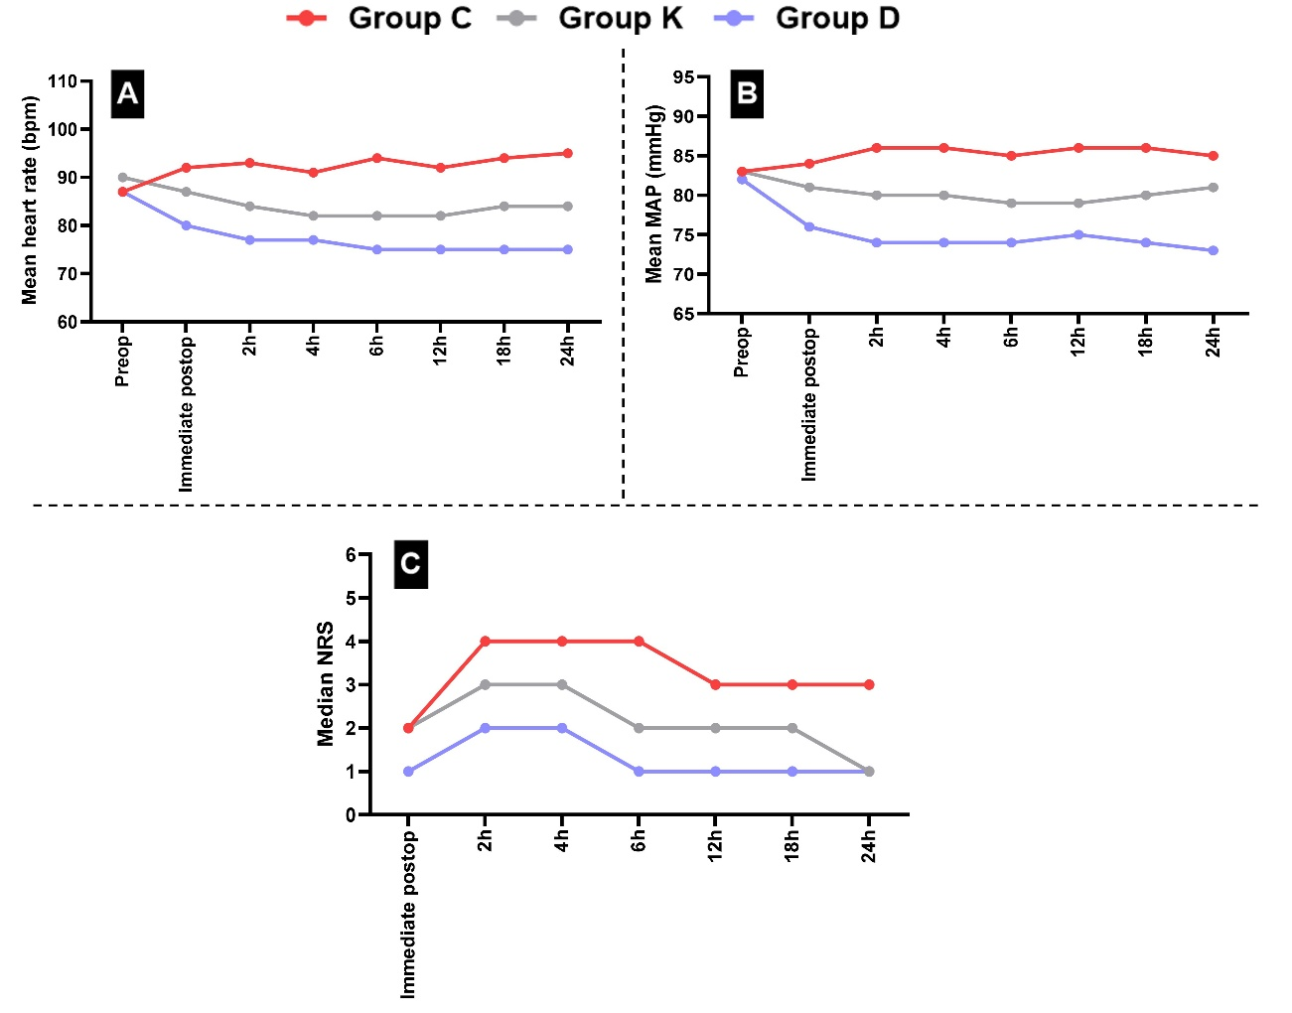
Figure 1: Changes in A) heart rate, B) mean arterial pressure, and C) pain scores during the perioperative period among the studied groups

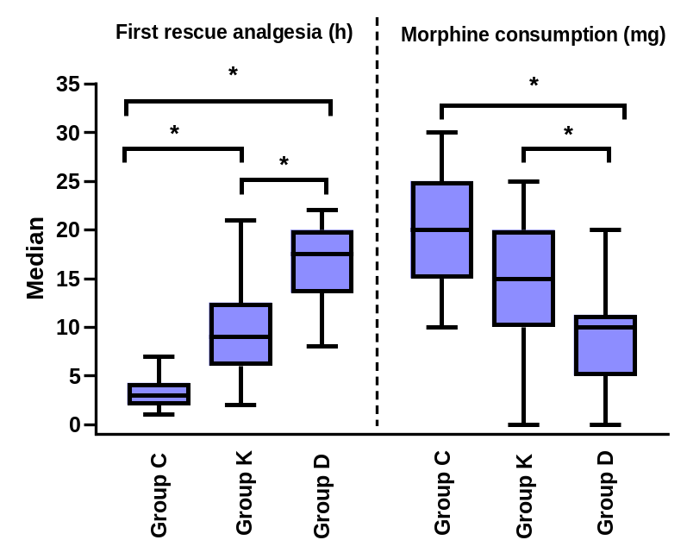
Figure 2: First rescue analgesia (h) and Total morphine consumption (mg) between the studied groups

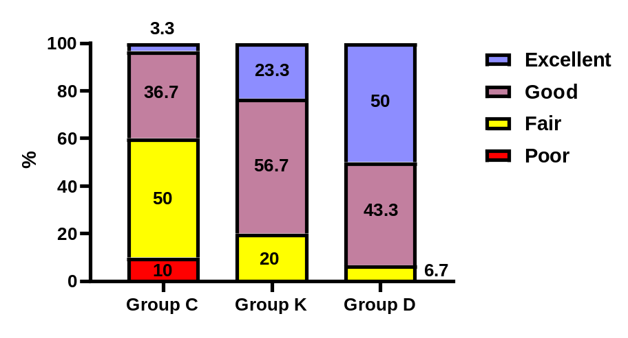
Figure 3: Patients’ satisfaction between the studied groups

